Name: _____________________________________________________ Date: _________________ Period: _______
Lesson 1.2.1 Problems 1-57 to 1-61
1-57. Joyce’s dad packs her lunch and always packs a yogurt. Joyce knows that there are five yogurts in the refrigerator: one raspberry, two strawberry, one blueberry, and one vanilla. Her dad usually reaches into the refrigerator and randomly grabs a yogurt.
a. Which flavor is she most likely to have in her lunch today?

b. What are her chances of finding a vanilla yogurt in her lunch bag?

1-58. Place the following probabilities on the number line below. (Put the letter for each scenario on the number line)

a. A 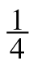 chance that you will be the team member who gets supplies tomorrow.
b. A 25% chance of snow tomorrow.
c. A 0.8 probability of eating vegetables with dinner.
d. P(blue marble) = 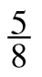.
e. A 0.01 probability that it will be 85° on Saturday.

1-59. Write “theoretical” or “experimental” to describe the probabilities for each of the following situations.
a. The chance of getting tails when flipping a coin is 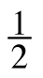. ________________________
b. I flipped a coin eight times and got heads six times, so the probability is 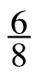.
________________________
c. My mom packed my lunch three of the past five days, so the probability of my mom packing my lunch is 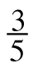. ________________________

d. The chance of winning the state lottery is 1 in 98,000,000. ________________________

e. Based on mathematical models, the chance of rain today is 60%.
________________________
f. Lena got three “hits” in her last seven times at bats, so her chance of getting a hit is 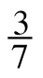.
________________________
1-60. FRACTIONS AND PERCENTS
Marianna represented several percents as portions of 100 in the pictures below.
Write the percent represented in each picture.
a. b. c.

____________ ____________ ____________
Write the portion represented in each picture as a fraction in at least two different ways.

____________ ____________ ____________
1-61. Find the mean and median for the lengths of the jumping frogs’ bodies shown below (the length are in centimeters).
20.3, 12.5, 7.6, 13.9, 9.2, 21.7, 7.6, 17.5, 15.6, 14.1

Mean: ______________________

Median: ______________________

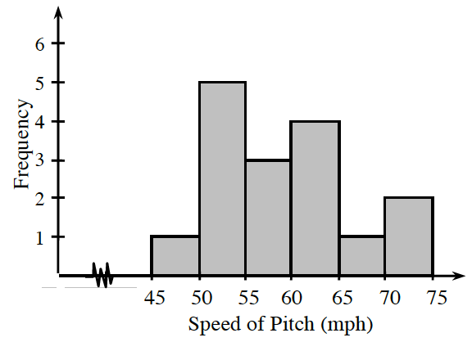
1-62. Craig is practicing his baseball pitching. He kept track of the speed of each of his throws yesterday, and made the histogram at right.
a. Can you tell the speed of Craig’s fastest pitch? Explain.

b. Between what speeds does Craig usually pitch?

c. Based on this data, what is the probability that Craig will pitch the ball between 70 and 75 miles per hour?

